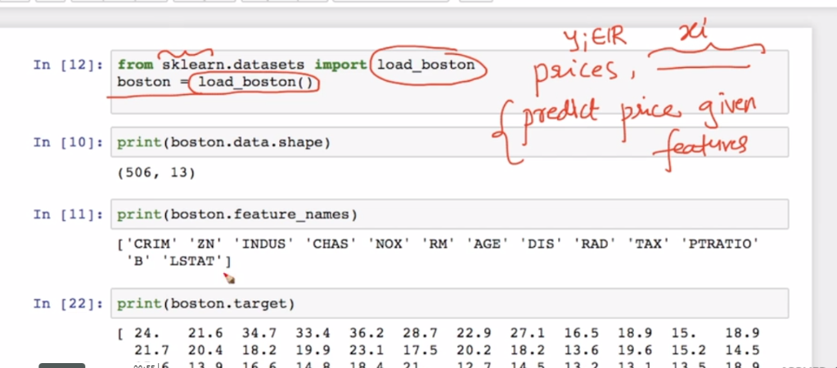

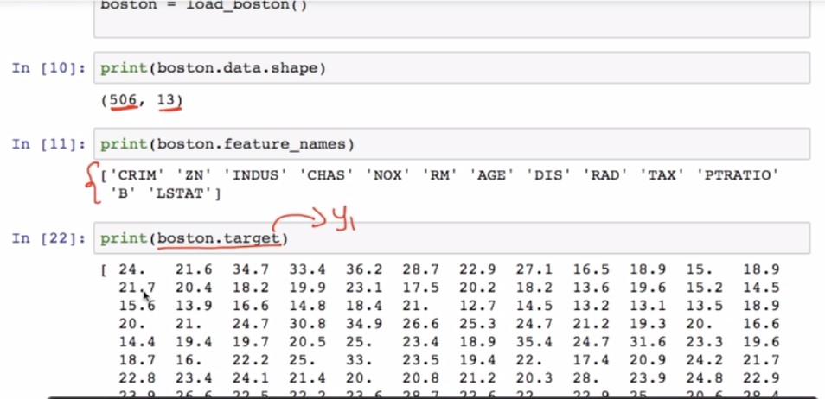

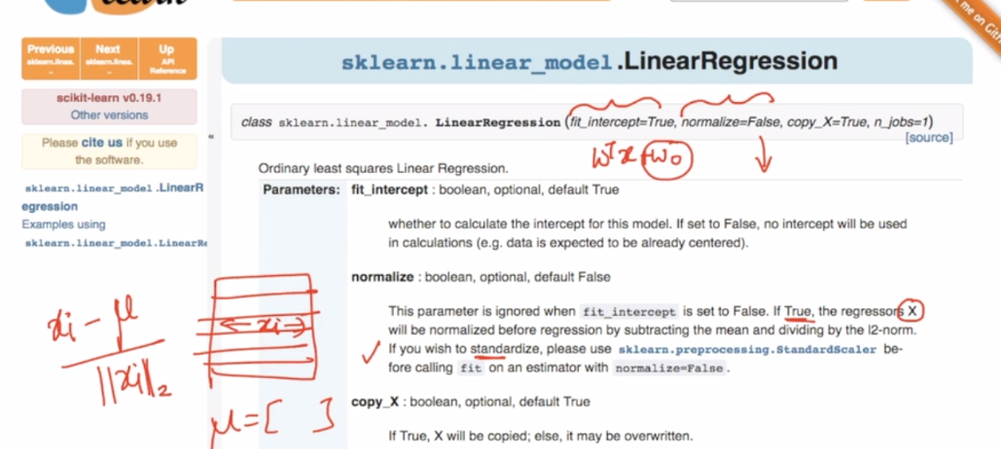

Whe normalize=True it normalize features using formula given in above image.

Note: Regularization is not available in sklearn.

But For regularization we have two diff for Linear reg.

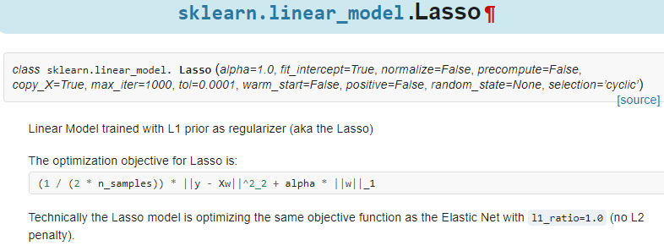

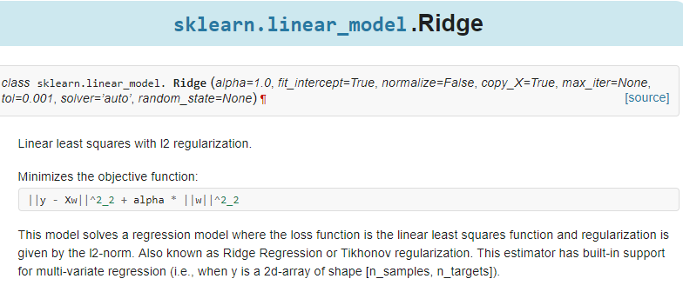

Below is error plot y-y^ in pdf form, we can see most of errors are 0.

Here we can see we are getting more –ve error so we will remove this.

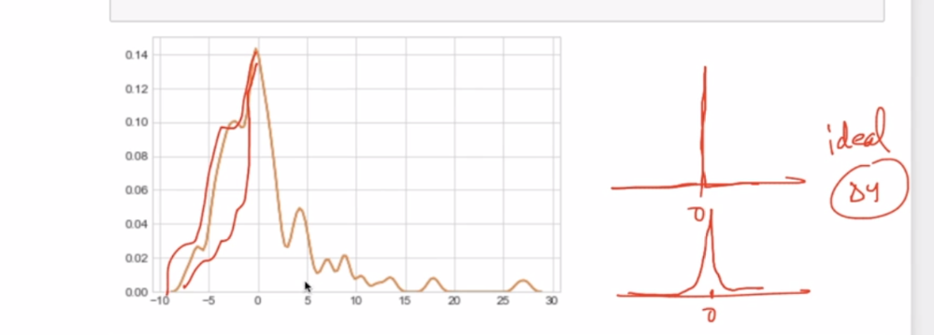

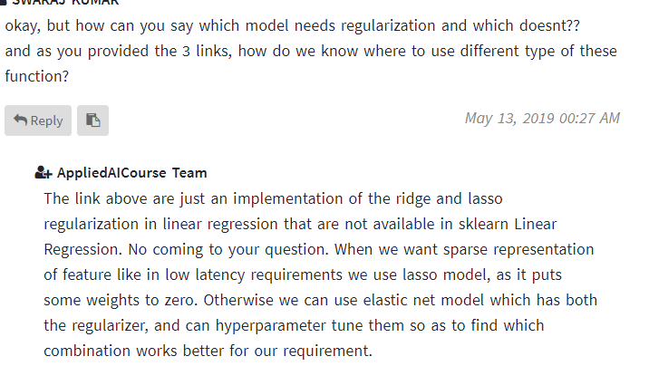

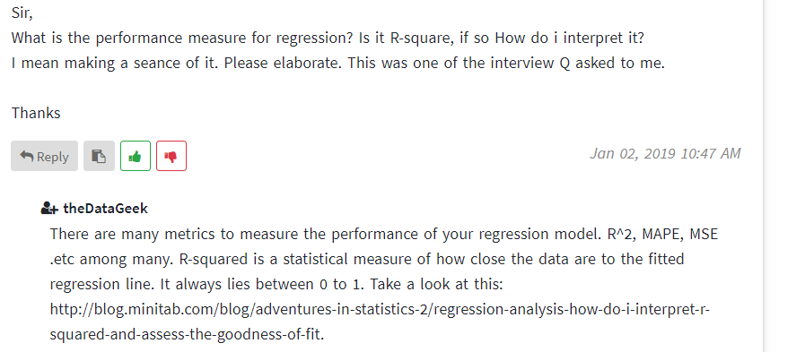

<https://blog.minitab.com/blog/adventures-in-statistics-2/regression-analysis-how-do-i-interpret-r-squared-and-assess-the-goodness-of-fit>

But R2 only can’t be used to check performance residual analysis should also be performed, must check link for residual analysis

<https://stattrek.com/regression/residual-analysis.aspx>